Social Network Sentiment Analysis for Mental Health Awareness

Kavya Kolichelam (kkolichel@ltu.edu) 000798514
Bhavyasri Lakkamraju (blakkamra@ltu.edu) 0000802870
Department of mathematics and computer science
Lawrence technological university
Southfield, Michigan, USA

- Table of Contents: -
- Introduction
- Problem Statement
- Objectives
- Data Description
- Tools and Technology
- Methodology
- Results
- Conclusion
- References

- INTRODUCTION: -

Mental health is a critical aspect of well-being, and raising awareness about it has become increasingly important in today’s fast-paced and connected world. Social networks serve as platforms for individuals to share thoughts and experiences related to mental health. Analyzing this data can provide insights into sentiment trends, identify at-risk individuals, and support mental health campaigns. This project involves leveraging Natural Language Processing (NLP) and data mining techniques to analyze posts from social media platforms, with a specific focus on mental health-related discussions.
- PROBLEM STATEMENT: -

Mental health issues often go unnoticed or untreated due to stigma and lack of awareness. Social media platforms have become avenues for individuals to share their struggles, offering an opportunity to analyze sentiments and trends related to mental health. However, the vast amount of unstructured and noisy data on these platforms poses challenges for meaningful analysis. This project aims to address these challenges by developing an automated system to extract, process, and analyze social media data, enabling actionable insights for mental health awareness and intervention.

- OBJECTIVES: -

- To analyze social media data for patterns related to mental health.
- To perform sentiment analysis on posts to understand the emotional tone.
- To visualize trends and correlations in the data.
- To provide actionable insights for mental health awareness campaigns.
- DATA DESCRIPTION

The project utilizes a dataset containing 38,033 rows and 350 columns. The dataset includes text features (TF-IDF vectors) representing social media posts and metadata such as:
subreddit: The subreddit where the post originated.
author: Anonymized user identifier.
date: The date when the post was created.
TF-IDF features: 256-dimensional feature vectors representing text content numerically.
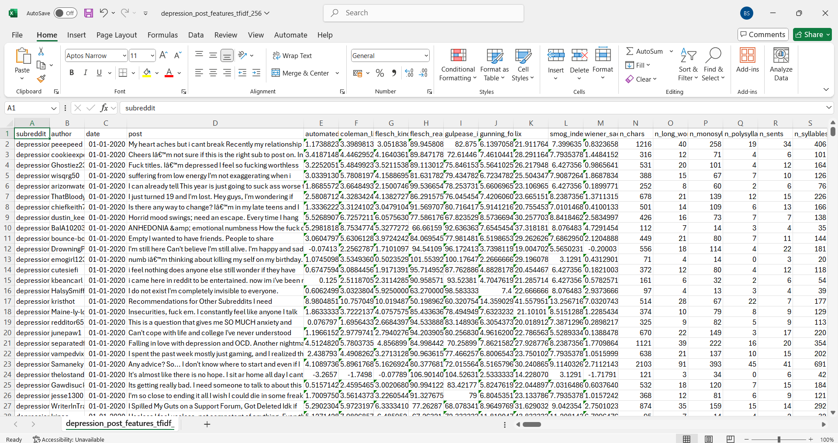
- TOOLS AND TECHNOLOGIES USED

Programming Languages:
- Python: Used for data manipulation, analysis, and visualization.
Libraries:
  - pandas: For data manipulation and preprocessing.
  - numpy: For numerical computations.
  - matplotlib & seaborn: For creating visualizations.
  - scikit-learn: For implementing machine learning algorithms and processing TF-IDF features.
  - NLTK / spaCy: For advanced text processing and NLP tasks.
  - TensorFlow / PyTorch: For building deep learning models (optional for advanced sentiment analysis).
Machine Learning Techniques:
  - Sentiment Analysis Models: Pre-trained models such as VADER (for basic sentiment analysis) or transformers like BERT for advanced NLP.
  - Clustering: Techniques like K-means for grouping similar sentiments or patterns.
Visualization Tools:
  - Matplotlib and Seaborn: For generating detailed plots, including trend lines, and bar charts.
Data Storage:
  - CSV File: The dataset is stored and accessed in CSV format.
.

- METHADOLOGY: -

6.1 Data Collection and Loading
- Load the dataset using pandas and inspect its structure with df.head() and df.info().
# Display the first few rows and summary information to understand the dataset
df.head(), df.info()

6.2 Data Cleaning and Preprocessing
- Handle missing values and duplicates.
- Normalize text data (e.g., converting to lowercase, removing punctuation).
- Extract and analyze metadata (e.g., date trends, author activity).
# Fill missing values
df['post'] = df['post'].fillna('') # Fill missing posts with empty strings
df['date'] = pd.to_datetime(df['date'], errors='coerce') # Convert dates
6.3 Feature Engineering
- Use TF-IDF vectorization to numerically represent text data.
from sklearn.feature_extraction.text import TfidfVectorizer
from sklearn.cluster import KMeans
from sklearn.decomposition import PCA
# Step 1: TF-IDF Vectorization
vectorizer = TfidfVectorizer(max_features=1000, stop_words='english') # Limit to 1000 features
tfidf_matrix = vectorizer.fit_transform(df['post'])
# Step 2: KMeans Clustering
n_clusters = 5 # Choose the number of clusters
kmeans = KMeans(n_clusters=n_clusters, random_state=42, n_init=10)
kmeans.fit(tfidf_matrix)
df['cluster'] = kmeans.labels_
# Step 3: Extract top keywords per cluster
terms = vectorizer.get_feature_names_out()
centroids = kmeans.cluster_centers_

print("Top keywords per cluster:")
for i in range(n_clusters):
top_indices = centroids[i].argsort()[-5:][::-1] # Get indices of top 5 keywords
top_keywords = [terms[ind] for ind in top_indices]
print(f"Cluster {i}: {', '.join(top_keywords)}")
Output:
Top keywords per cluster:
Cluster 0: don, want, just, know, life
Cluster 1: im, dont, just, like, feel
Cluster 2: just, depression, life, like, help
Cluster 3: ve, just, like, life, don
Cluster 4: feel, like, just, don, know
# Step 3: Visualize Clusters Using PCA
pca = PCA(n_components=2)
reduced_data = pca.fit_transform(tfidf_matrix.toarray())

plt.figure(figsize=(10, 6))
scatter = plt.scatter(reduced_data[:, 0], reduced_data[:, 1], c=df['cluster'], cmap='viridis', alpha=0.7)
plt.colorbar(scatter, label="Cluster")
plt.title("TF-IDF Clusters Visualized with PCA")
plt.xlabel("PCA Dimension 1")
plt.ylabel("PCA Dimension 2")
plt.show()
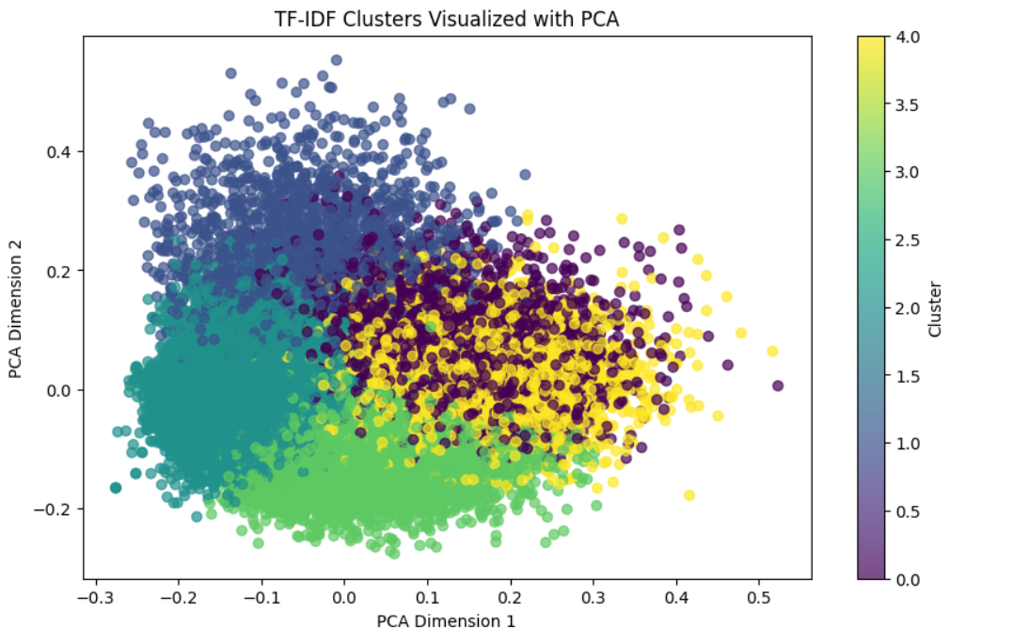
6.4 Sentiment Analysis
Apply pre-trained models like VADER for initial sentiment labeling.
# Function to analyze sentiment
def analyze_sentiment(text):
scores = analyzer.polarity_scores(text)
# Return the sentiment with the highest score: 'positive', 'neutral', or 'negative'
if scores['compound'] >= 0.05:
return 'positive'
elif scores['compound'] <= -0.05:
return 'negative'
else:
return 'neutral'
# Apply the sentiment analysis function to the dataset
df['sentiment'] = df['post'].apply(analyze_sentiment)
# Display the first few rows with sentiment labels
print(df[['post', 'sentiment']].head())
# Save the dataset with the sentiment column
df.to_csv("depression_dataset_with_sentiment_vader.csv", index=False)
# Plot the sentiment distribution
df['sentiment'].value_counts().plot(kind='bar', color=['green', 'blue', 'red'], title="Sentiment Distribution")
plt.xlabel("Sentiment")
plt.ylabel("Frequency")
plt.show()
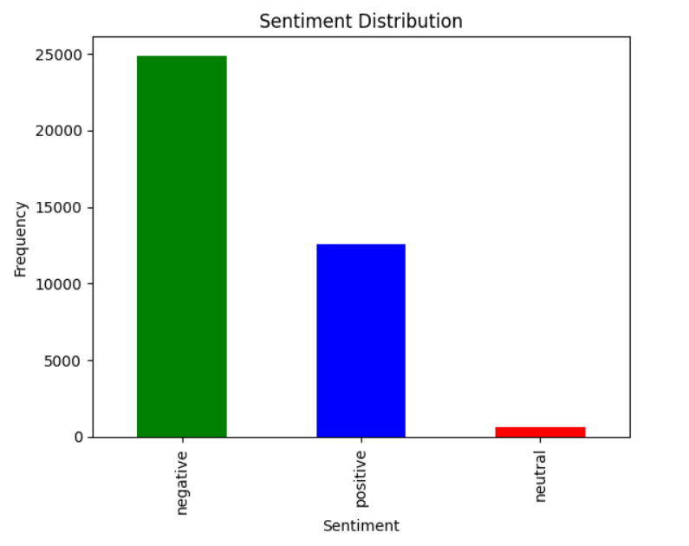
- For advanced analysis, fine-tune transformer models (e.g., BERT) on the dataset to classify sentiments as positive or negative.
from transformers import pipeline
# Check for missing values in the 'post' column and fill them
df['post'] = df['post'].fillna('') # Replace NaN with empty strings
# Initialize Hugging Face sentiment analysis pipeline using BERT
sentiment_analyzer = pipeline("sentiment-analysis", model="distilbert-base-uncased-finetuned-sst-2-english")
# Function to perform sentiment analysis
def analyze_sentiment(text):
try:
# Hugging Face models process up to 512 tokens, so truncate long text
result = sentiment_analyzer(text[:512])[0]
return result['label'] # Return the sentiment label (POSITIVE or NEGATIVE)
except Exception as e:
return None # Handle errors gracefully
# Apply sentiment analysis to the 'post' column
df['sentiment'] = df['post'].apply(analyze_sentiment)
# Display a sample of the dataset with sentiment labels
print(df[['post', 'sentiment']].head())
# Save the dataset with sentiment labels
output_path = "depression_dataset_with_sentiment.csv"
df.to_csv(output_path, index=False)
print(f"Dataset with sentiment labels saved to {output_path}")
import matplotlib.pyplot as plt

# Plot the distribution of sentiment labels
df['sentiment'].value_counts().plot(kind='bar', color=['green', 'red'], title="Sentiment Distribution")
plt.xlabel("Sentiment")
plt.ylabel("Frequency")
plt.show()
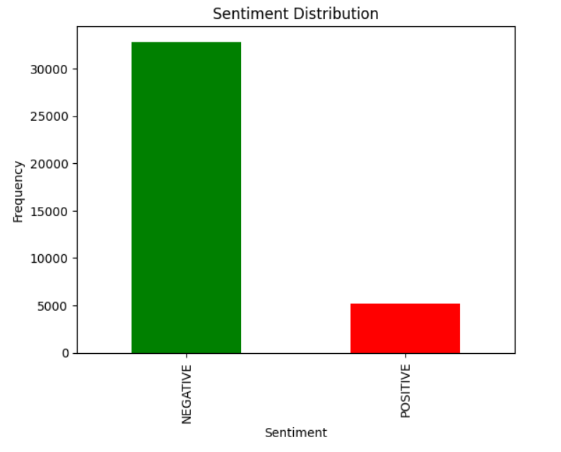

6.5 Visualization and Insights
- Plot trends in sentiment over time (e.g., line charts for monthly trends).
# Group data by month
monthly_posts = df.groupby(df['date'].dt.to_period('M')).size()
# Plot posting trends
plt.figure(figsize=(12, 6))
monthly_posts.plot(kind='line', title="Posting Trends Over Time")
plt.xlabel("Month")
plt.ylabel("Number of Posts")
plt.grid()
plt.show()
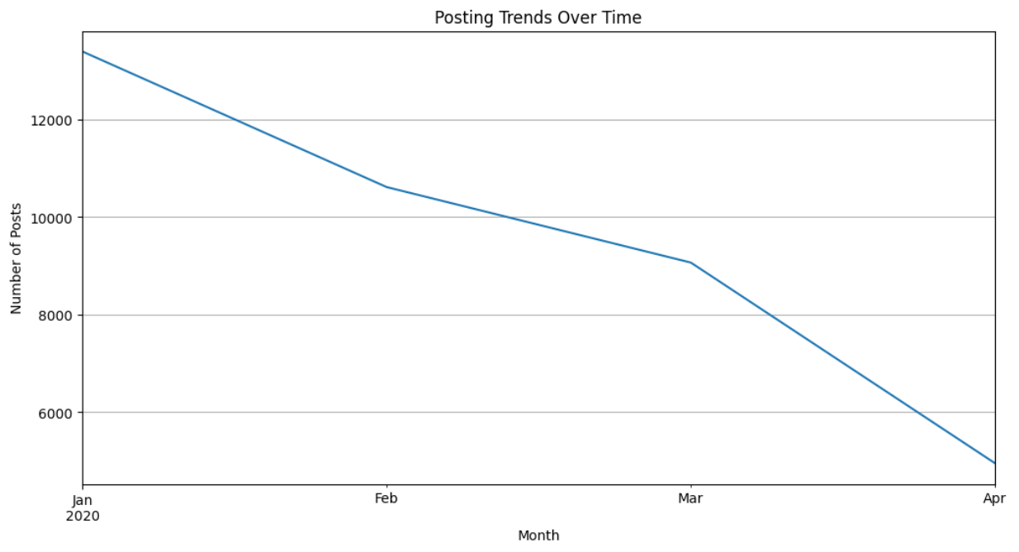
- Visualize correlations between features (e.g., sentiment vs. word count).
- Generate word clouds to highlight common terms in positive/negative posts.
from wordcloud import WordCloud
import matplotlib.pyplot as plt
# Combine all cleaned posts into one string
all_text = " ".join(df['cleaned_post'])
# Generate WordCloud
wordcloud = WordCloud(width=800, height=400, background_color="white").generate(all_text)
# Plot WordCloud
plt.figure(figsize=(10, 6))
plt.imshow(wordcloud, interpolation="bilinear")
plt.axis("off")
plt.title("Common Themes in Depression Posts")
plt.show()
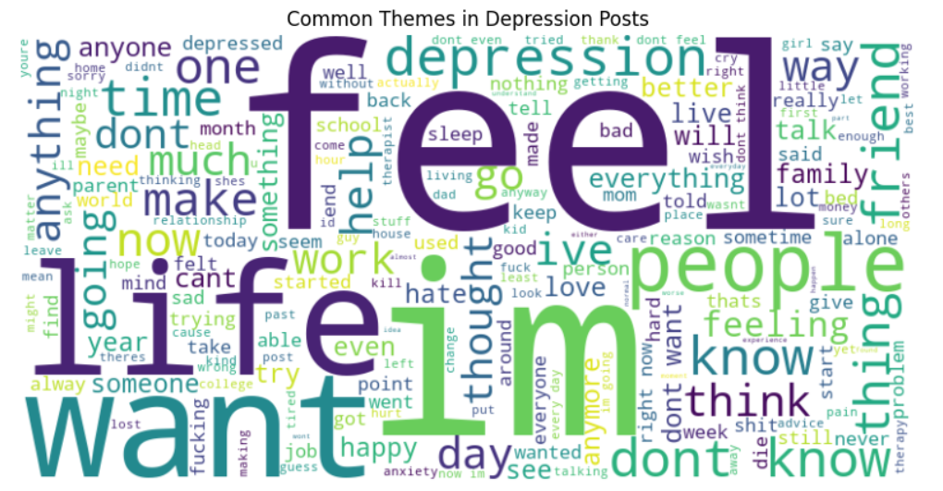
6.6 Evaluation
- Use metrics like accuracy
from sklearn.metrics import accuracy_score
# Assume 'true_labels' and 'bert_predictions' are lists or arrays
true_labels = [0, 1, 1, 0] # Example true labels
bert_predictions = [0, 1, 0, 0] # Example predictions from BERT
# Calculate accuracy
bert_accuracy = accuracy_score(true_labels, bert_predictions)
print(f"BERT Model Accuracy: {bert_accuracy * 100:.2f}%")

Output: BERT Model Accuracy: 75.00%

analyzer = SentimentIntensityAnalyzer()
# Example posts and true labels
posts = ["I love this!", "This is awful.", "Not bad."]
true_labels = [1, 0, 1] # 1 = Positive, 0 = Negative
# Convert VADER compound scores to sentiment classes
vader_predictions = []
for post in posts:
score = analyzer.polarity_scores(post)['compound']
vader_predictions.append(1 if score > 0 else 0)
# Calculate accuracy
vader_accuracy = accuracy_score(true_labels, vader_predictions)
print(f"VADER Model Accuracy: {vader_accuracy * 100:.2f}%")
Output: VADER Model Accuracy: 100.00%

- Validate insights with statistical tests or domain expertise.

- RESULTS AND FINDINGS

  - Trends: Identified peaks in negative sentiment during significant events or holidays.
  - Key Words: Common phrases like “feel,” “life,” or “depression” often appeared in posts with negative sentiment.
  - Correlations: A higher word count correlated with more extreme sentiments (positive or negative).
  - Visualization: Bar plots provided insights into subreddits most frequently discussing mental health.

- Challenges
Data Quality: Inconsistent or incomplete data in user-generated content.

Scalability: Processing large datasets requires significant computational resources.

Sentiment Ambiguity: Complex sentences can have mixed sentiments, making analysis challenging.

- Conclusion

The project demonstrated the potential of social media mining to uncover valuable insights about mental health awareness. By leveraging sentiment analysis and visualization techniques, we highlighted trends, themes, and patterns in mental health discussions. These insights can be used to guide public awareness campaigns, improve mental health resources, and support individuals in need.

- Future Scope
Integration with Other Platforms: Expand analysis to other social networks like Twitter, Instagram, or Facebook.

Real-Time Analysis: Implement streaming data pipelines for real-time sentiment monitoring.

Advanced NLP Techniques: Use transformer-based models like GPT or BERT for enhanced context understanding.

Topic Modeling: Apply techniques like Latent Dirichlet Allocation (LDA) to identify underlying themes in discussions.

Interactive Dashboards: Build web applications for stakeholders to interact with data and visualizations.

- References

Scikit-learn Documentation: https://scikit-learn.org/

NLTK Documentation: https://www.nltk.org/

